Street Address: 34 Meson Street, Gayndah
Postal Address: PO Box 391, Gayndah, QLD, 4625
Telephone (07) 4140 8057
Email: gayndahgallery@gmail.com
Like us on Facebook
Visit our website: gayndahartgallery.com.au

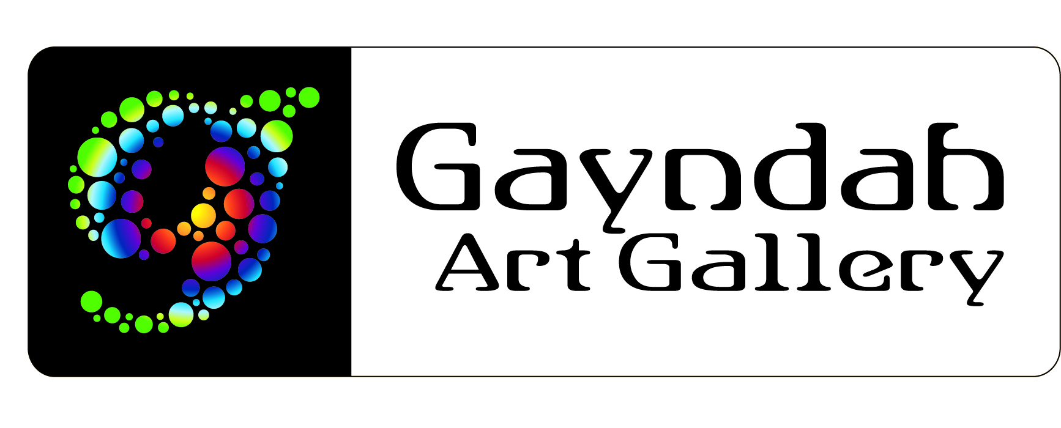
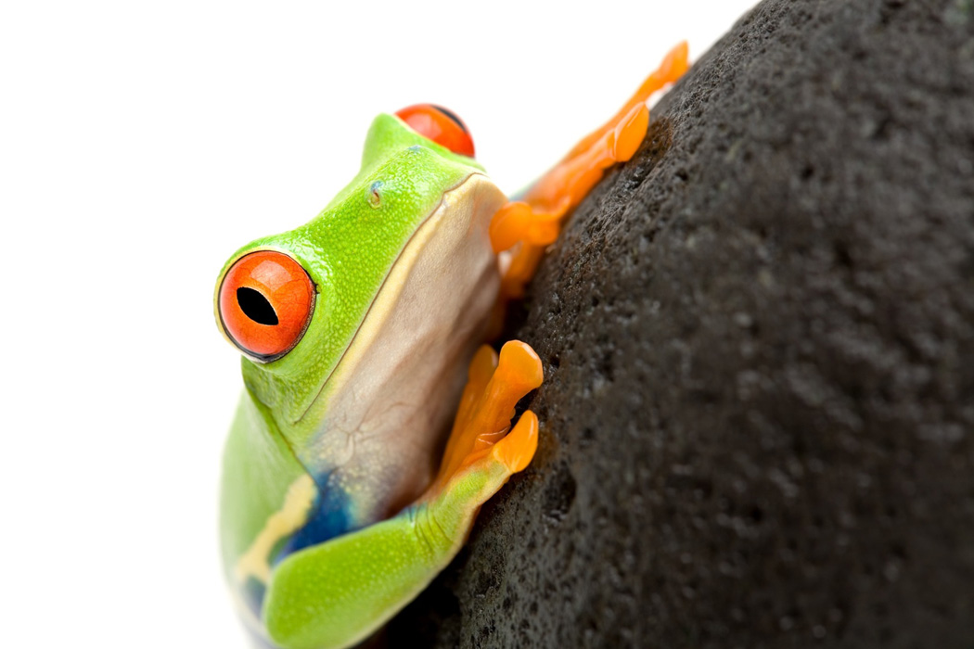

FROGGs & FROGGLETs

Friends of Gayndah Gallery & Junior Friends Under 16

MEMBERSHIP APPLICATION FORM

Registration Type: INDIVIDUAL: $15 COUPLE: $25 FROGLET $5

PERSON #1
Surname: _______________________________________________________________
Given Name(s): _______________________________________________________________

PERSON #2
Surname: _______________________________________________________________
Given Name(s): _______________________________________________________________
FROGGLET/s
Surname: _______________________________________________________________
Given Name (s) _______________________________________________________________
Date of Birth: _______________________________________________________________
CONTACT DETAILS
Mailing Address: _______________________________________________________________
Suburb: _______________________________ Postcode: ____________
Home Phone: (07) ___________________________________________________________
Mobile Phone: Person #1: ____________________________________________________
Person #2: ____________________________________________________
Email Address: _______________________________________________________________
Friends of Gayndah Gallery and Junior Friends under 16

FROGGs and FROGGLETs

MEMBERSHIP APPLICATION FORM

DECLARATION

In completing and signing this Friends of Gayndah Gallery Membership Application Form, I/we acknowledge and accept the following Terms & Conditions:

- The period of membership is per calendar year (March 1st to February 28/29th).
- Members will receive a numbered badge on payment of membership fee. Replacement of lost badges will be the responsibility of the member. Available from Kencraft.
- Members are entitled to visit the Gayndah Art Gallery outside of the normal hours of operation by appointment.
- Members will receive email notification of upcoming Gayndah Art Gallery special events/functions.
- Members will receive automatic entry into Gayndah Art Gallery MEMBERS ONLY prize draws, whether they are in attendance or not.
- Members are entitled to receive other benefits as offered by the Gallery.
- Acceptance of Membership is entirely at the discretion of the Gayndah Art Gallery Committee.

Signature of Person #1: _______________________________________ Date: _______________

Signature of Person #2: _______________________________________ Date: _______________

Signature of Frogglet #1________________________________________Date: _______________
Signature of Frogglet #2________________________________________Date: ________________

Membership Fees will be due on 1st March in each calendar year. Upon receipt of first year fees, members will be issued with one numbered badge each, as illustrated below.

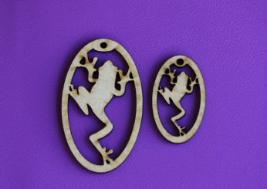

Bank details for transfers:
BSB 084 560
Account Number 94954 9454
Account Name Friends of Gayndah Gallery

